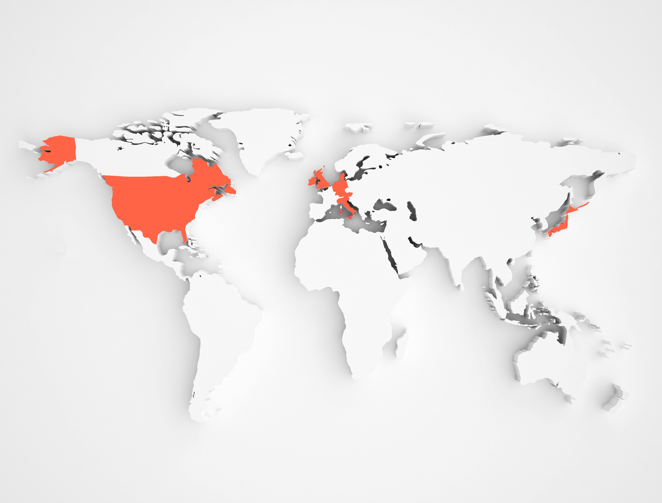
1986 QVC is launched in the U.S.A.
1993 QVC United Kingdom launched
1996 QVC Germany launched
2001 QVC Japan launched
2010 QVC Italy launched

Qurate Retail, Inc. QVC®, HSN®, Zulily® and the Cornerstone brands (collectively, “Qurate Retail GroupSM”), as well as other minority interests and green energy investments
NASDAQ: QRTEA, QRTEB, QRTEP

QVC, Inc. QVC US, HSN, and QVC International (QVC UK, QVC Germany, QVC Japan, QVC Italy)

QVC International QVC UK, QVC Germany, QVC Japan, QVC Italy

QVC® is a world leader in video commerce (“vCommerce”), which includes video-driven shopping across linear TV, ecommerce sites, digital streaming and social platforms. QVC empowers shoppers with knowledge and shares insights in a lively and engaging way. QVC offers an ever-changing collection of familiar brands and fresh new products – from home and fashion to beauty, electronics and jewelry – and connects shoppers to interesting personalities, engaging stories and award-winning customer service.
Based in West Chester, Pa., and founded in 1986, QVC has retail operations in the U.S., the U.K., Germany, Japan and Italy. QVC reaches more than 200 million homes via its 12 broadcast networks and reaches millions more via multiple streaming services, websites, mobile apps and social pages.

QVC International brings the QVC shopping experience to millions of people in Germany, Austria, Japan, the U.K., Ireland and Italy. QVC International reaches 124 million homes via nine television networks and reaches millions more via multiple websites, mobile apps, smart TV apps and social pages. In 2021, QVC International served 4.7 million customers. QVC International has more than 7,000 team members in the U.K., Germany, Japan, Italy, Poland and China.

Qurate Retail, Inc. (NASDAQ: QRTEA, QRTEB, QRTEP) includes QVC, HSN®, Zulily® and the Cornerstone brands (collectively, “Qurate Retail GroupSM”), as well as other minority interests and green energy investments. Qurate Retail Group is dedicated to providing a more human way to shop and is the largest player in vCommerce. For more information, visit www.qurateretailgroup.com, follow @QurateRetailGrp on Facebook, Instagram or Twitter, or follow Qurate Retail Group on YouTube or LinkedIn. QVC and Q are registered service marks of ER Marks, Inc.

Qurate Retail Group Facts
- Nearly 22M+ customers
- The largest player in video commerce (vCommerce), which includes video-driven shopping across linear TV, ecommerce sites, digital streaming and social platforms
- More than 200M homes reached worldwide via 14 television networks
  - Nearly 130 hours/day of live programming
  - On cable/satellite, free over-the-air, and pay digital livestreaming TV (YouTube TV, Hulu+ Live TV, DirectTV, Sling TV)
- Millions more homes reached through digital platforms, including:
  - Social streaming on Facebook, YouTube, Instagram, TikTok
  - Websites and apps
- 2.5B digital sessions⁽¹⁾
- 316M units shipped, 20 fulfillment centers⁽²⁾
- 24,000+ team members⁽³⁾ in the U.S., the U.K., Germany, Japan, Italy, Poland and China
- $14 B in annual revenue
  - ecommerce revenue of $8.8 billion or 63% of annual revenue⁽⁴⁾

All data as of FY 2021, unless otherwise noted. (1) Includes web, mobile web and apps. (2) Excludes Rocky Mount, which has closed due to the fire on December 18, 2021. (3) Excludes approx. 2,000 Rocky Mount employees who were separated from the Company due to the fire on December 18, 2021. (4) Based on net revenue.

QVC, Inc. (QVC US, HSN, and QVC International) Facts
- 15M+ customers
  - 94% of sales come from repeat/reactivated customers
- $11.4B in 2021 revenue
  - ecommerce revenue of $6.5B or 57% of total sales⁽¹⁾
- More than 200M homes reached worldwide via 14 television networks
  - Nearly 130 hours/day of live programming
  - On cable/satellite, free over-the-air, and pay digital livestreaming TV (YouTube TV, Hulu+ Live TV, DirectTV, Sling TV)
- Millions more homes reached through digital platforms, including⁽²⁾:
  - Interactive streaming shopping service (on Roku, Comcast X1 and Xfinity Flex, Amazon Fire TV, LG, Apple TV, Android TV, Google Play Store, & Google TV)
  - Digital livestreaming TV on free services (XUMO, STIRR); and streaming devices/smart TV services (Samsung TV Plus, LG Channels, Xfinity Flex, VIZIO SmartCast)
  - Social streaming on Facebook, YouTube, Instagram, TikTok
  - Websites and apps
- 1.7B digital sessions⁽²⁾
- 236M units shipped, 12 fulfillment centers⁽³⁾
  - 114M customer calls
- 20,000 team members⁽⁴⁾ in the U.S., the U.K., Germany, Japan, Italy, Poland and China
All data as of FY 2021, unless otherwise noted. (1) Based on net revenue. (2) Includes web, mobile web and apps. (3) Excludes Rocky Mount, which has closed due to the fire on December 18, 2021. (4) Excludes approx. 2,000 Rocky Mount employees who were separated from the Company due to the fire on December 18, 2021.

QVC International
- 4.7M customers
- $3.1B in 2021 revenue
  - ecommerce revenue of $1.5B or 47% of total sales⁽¹⁾
  - mobile represented 73% of ecommerce sales⁽²⁾
- 124M homes reached, primarily in Germany, Austria, Japan, the U.K., Ireland and Italy
  - 9 television networks, 70+ hours/day of live programming
- Millions more homes reached through websites, mobile apps, smart TV apps, social pages
  - Nearly 450M digital sessions⁽³⁾
- 69M units shipped, 4 fulfillment centers
- 7,000+ team members in the U.K., Germany, Japan, Italy, Poland and China

All data as of FY 2021. (1) Based on net revenue. (2) Based on gross US Dollar orders. (3) Includes web, mobile web and apps.

QVC Italia
Headquarters Brugherio (MB) – Head office
Castel San Giovanni (PC) – Logistics Center

- Multiplatform video retailer TV channels, DDT, tivùsat 32, tivùsat HD 132, Sky and Sky HD 475, website, social pages, livestreaming app likeQ
- Launch of the e-commerce in December 2011, optimization for smartphones and tablets. Mobile App. Website restyling with a focus on the storytelling, more moments for the community
- Broadcast network reaches 25 million households
- Broadcast channel is a semi-generalist channel which theme is women’s empowerment in each content, both in those of shopping and information
- TV, web and social pages are complementary
- QVC Play – TV on demand
- Focus on storytelling (guest as product specialist – presenter). Tutorial videos that can be viewed both live and via website, social live streaming
- Live shows for 17 hours a day, 364 days a year
- 21 presenters and hundreds of guests
- Payment methods: cash on delivery, credit card, QPay (installment payments)
- Time of delivery: 3/5 working days
- 30-day-money-back guarantee after the delivery day
- Contact center open 24/7

Offer
- Expansion of the categories with subcategories: men’s clothing food, superfood, toys, pet products, DIY items
- Among the offered brands: Philips, Samsung, Kitchen Aid, De Longhi, Sony, Huawei, Kipling, Dyson, Perricone, Oppo, Smeg, Coin, Nomination
- Dropshipment

Partnership
- High-profile partnerships with accredited bodies such as: Netcomm, Retail Institute

Locations
2010: Brugherio headquarters, studios and contact center: 15.000 sqm for TV studios equipped with recording and broadcasting systems in line with the most advanced standards and technologies.
2013: Castel San Giovanni (near Piacenza) distribution and logistics center: Took over shipping from QVC Germany, reduced delivery time from 5/8 days to 3/5 working days.

Information for the media

QVC Italy Press office:

ad Mirabilia
- Sarah Pari – pari@admirabilia.it - +39 340 9096543
- Laura Sanfelici - sanfelici@admirabilia.it - +39 346 6302391

QVC Italy
- Michele Tanci – michele.tanci@qvc.com – tel. 349 0971166
- Sabrina Pigola - sabrina.pigola@qvc.com - tel. 349 6049402

